Promotional Materials for
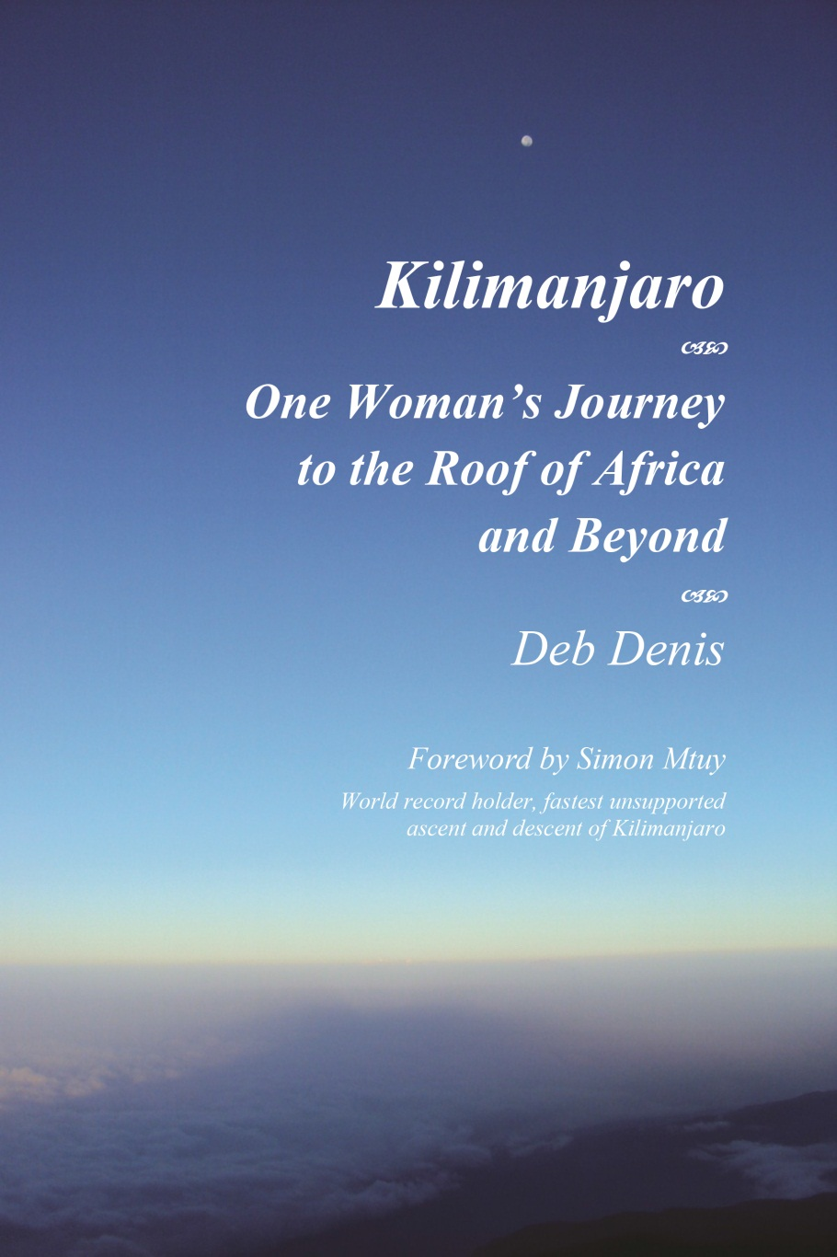

What’s Inside . . . .

Synopsis 1
Early Reviews 2
About the Author (with photo) 3
Publisher 4
How to Buy 5
Contact Information 5
Book Clubs, Speaking 6
Multimedia - bringing the story alive 7
Suitable for publication @ 200 Words 8
Suitable for publication @ <900 Words 9
Copyright and Permissions 11

Synopsis

When she was forty-five years old, non-athlete Deb Denis set a goal to climb Africa’s tallest peak before she turned fifty. She knew she could train up for the challenge—she had five years to get ready for it, after all. The opportunity to go to East Africa presented itself before she knew it, much sooner than she expected, and at a time when she and her family were in crisis.

Hear the story of one brave woman’s journey—how she prepared to go it alone and the heart-wrenching life lessons she learned along the way, lessons that will have meaning for anyone who has experienced challenges and loss in their own life.

A PDF COPY OF THE MANUSCRIPT IS AVAILABLE FOR PRESS and MEDIA, VIA EMAIL, ON REQUEST. Send request to: DD@MarionGracePublishing.com

Early Reviews

“I couldn’t put it down. Kilimanjaro is a wonderful metaphor that carries the author’s story: the difficult encounter with her own “Self” and the courage and determination to work through it. There are many stories laced throughout, all of them linked by the methodic narrative of the “process of the climb.” Deb opens a window for us and she invites us to look through . . . I was drawn by the courage she had to tell us her soul’s journey and I wanted to know more. I love it.”
—Letizia Amadini-Lane, Vice President, Global Employee Value Proposition, GlaxoSmithKline

“Get ready for the journey of a lifetime! Deb Denis takes you with her, step by step, as she climbs the rugged slopes of Mount Kilimanjaro—and ventures deep into the yearning for adventure that lives inside us all. Her warm compassion, light-hearted humor and soul-baring honesty will take you on an inner journey too, bringing laughter and tears, along a trail that opens you to the endless possibilities of life. Like a trusted friend, this caring and adventurous woman will help you discover what it means to follow your heart and live with courage.” —Deb Giffen, Director, Innovative Learning Solutions, Wharton Executive Education

“Possibly the most comprehensive account of one person’s climb I’ve come across, covering not only why and when she did it but, most important of all, how she did it. Clearly venturing out of her comfort zone, Deb spent one year preparing for her African adventure, which begins in one of the smallest countries on the continent and ends on its largest mountain. The story of her journey—in both the physical and the personal sense—is an entertaining and thought-provoking one.” —Henry Stedman, Author, “Kilimanjaro, A Trekking Guide to Africa’s Highest Mountain”

“I really enjoyed the book. I particularly liked the personal and practical insights you had about the experience and your descriptions of the days on the climb from Lava Tower to the summit and then to Millennium. The practical information about your research process will be very useful for readers. Thanks for the kind words about SENE. I’m glad that you also listed and described some of the other companies that you considered, as different outfitters work better for different people.” —Tim Leinbach, Director, U.S. Operations, Summit Expeditions & Nomadic Experience

About the Author (with photo)

Deb Denis is an Executive Coach and Organizational Consultant who helps her clients blast through barriers to master more change than they previously thought possible. She’s done this with hundreds of clients from all around the world and at varying levels within many industries.

Deb is Partner and Co-Founder of the Athena Project, LP (www.athenaproject.us), a firm focused on developing leaders, with particular expertise in developing women leaders to help businesses solve the “pipeline problem.” In 2010 she founded Coaches Without Borders (www.coaches-without-borders.org), an international volunteer organization that pairs U.S.-trained Executive Coaches with leaders of aid organizations in Africa.

Deb loves to experience the world and has travelled, hiked and eaten on all six inhabited continents. Deb was born in Philadelphia, raised in upstate New York, and lives outside Philadelphia with her husband Alan and their golden retriever, Athena.

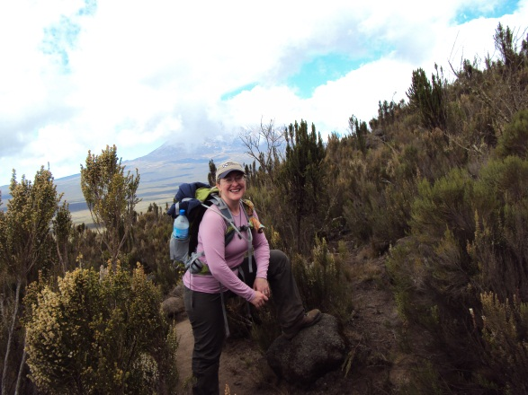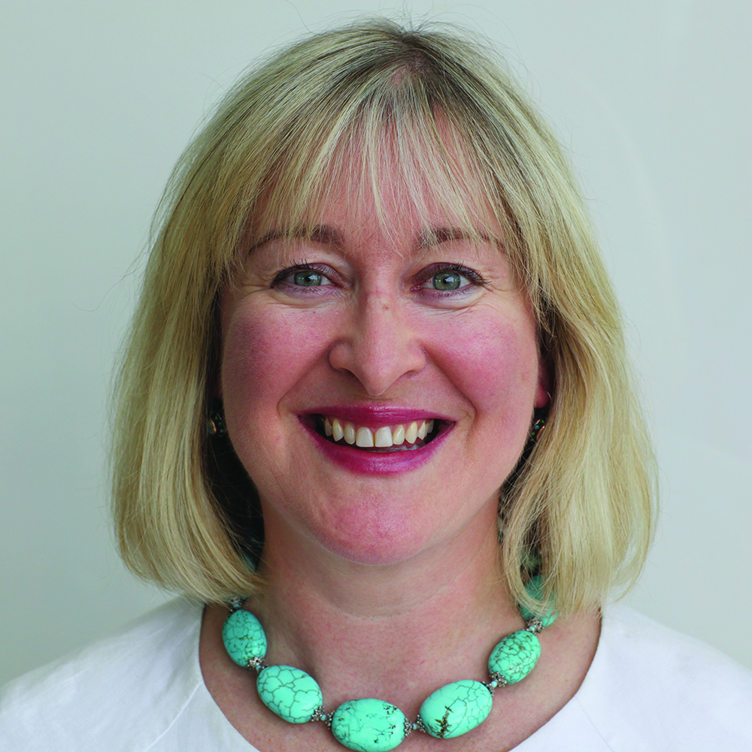

www.hersolosummit.com
www.debdenis.com

Publisher

About Marion Grace Publishing - www.mariongracepublishing.com
Marion Grace Publishing was established in 2012 as an independent book publisher. The company is named after the author’s grandmother, Marion Grace Eckenroth, who was born in Lancaster, Pennsylvania. Marion was a daughter, sister, cousin, student, and later, an “Estee Lauder Girl” who loved going “down the shore.”
Marion met her husband on Steel Pier in Atlantic City, where she saw the famous diving horse. She had three beautiful daughters who shared the initials SJS, and all the monogrammed sweaters that came after. She loved to take her daughters and grandchildren to Ocean City, New Jersey.
She was a teacher in the school district of Philadelphia during the mid-20th century and had a love of learning, all things cultural and her family. She loved animals and funded care for some via the Philadelphia Zoo and National Geographic Society. She had an appreciation for the finer things. She taught the next generations—her students and her family—about reading, writing and Philadelphia history.
Marion was born in 1910 and lived to see another century; she died in 2000.


Marion Grace Publishing
U.S.A.

www.MarionGracePublishing.com

Marion Grace Publishing
P.O. Box 198, Newtown Square, PA 19073

How to Buy

Support the Author! Purchase books & eBooks (Kindle, Nook, iReaders) directly from Marion Grace Publishing. BONUS: All copies purchased directly from the publisher will be signed by the author. Include a note with your order if you’d like the book dedicated to anyone by name.

Are you ordering 10 copies or more? Contact us. We ship globally.

Retail Price $20 / Direct-From-Publisher Price $14.99 / eBook Price $9.99

Also available via www.Amazon.com (paperback* & Kindle versions), Barnes and Noble.com (for Nook readers) and iStore / iTunes for iReaders*.

*Late Summer 2012

Contact Information

Deb Denis
Founder, Marion Grace Publishing
Author, Kilimanjaro, One Woman’s Journey to the Roof of Africa and Beyond.

Email: DD@mariongracepublishing.com

Telephone: (U.S. EST) +1.610.590.1446

Mailing Address: P.O. Box 198, Newtown Square, PA 19073

Book Clubs, Speaking

I am a social bee and, for me, life is about connections. Connections to adventurers. Connections to dreamers. Connections to readers, travelers, barrier-breakers, under-dogs and over-achievers. I enjoy connecting with other people who love, cry, yearn, regret, jump for joy, make mistakes and wonder why.

I would love to meet with your book club. I would be thrilled to support your bookstore, or adventure supplier, or group that gathers to inspire, educate, CONNECT.

Let’s connect!

DD@mariongracepublishing.com / +1.610.590.1446
P.O. Box 198, Newtown Square, PA 19073

Please consider buying your book directly from my publisher, Marion Grace Publishing. To show my thanks, I will sign and dedicate (at your request) all paperbacks purchased directly from Marion Grace Publishing.

Multimedia - bringing the story alive

www.hersolosummit.com

Kilimanjaro – One Woman’s Journey to the Roof of Africa and Beyond, by Deb Denis, is scheduled to be published in Summer 2012, one year after the author’s solo summit of Mt. Kilimanjaro.

The author created a website (www.hersolosummit.com) to bring you a multi-media experience including photographs, audio and video taken during her month-long journey in East Africa.

The website brings you what a book cannot: here you can hear Deb’s words in recordings made on the mountain, see the landscape in her videos and photographs.

Combined, the book and the website allow you to hear and share in the story of one brave woman’s journey. Find out how she prepared to go it alone and the life lessons she learned along the way, lessons that will have meaning for anyone who has experienced challenges in their own life.

When you believe in yourself, big things are possible.

Excerpt from the book:

I created a website to go with the book, ww.HerSoloSummit.com, where you’ll find some of the actual recordings—my way to share with you the spontaneous emotion of particular moments. When I wasn’t focused on breathing, walking slowly and drinking water, I was talking to my guides about the landscape and taking pictures, which you’ll also see on the website. On many of the later days of the climb I took short videos at camp, which I shared with family and friends when I got home. Their enthusiastic responses to this media convinced me the videos needed to be included, so it’s all available to you on the website.

By seeing and hearing my story through the recordings, the pictures and the videos on the website, I hope you’ll get a sense of what this experience was like. Come along on the adventure with me . . . .

Suitable for publication @ 200 Words

When she was forty-five years old, Deb Denis (non-athlete), set a goal to climb Africa’s tallest peak before she turned fifty. She knew she could train up for the challenge—she had five years to get ready for it, after all. The opportunity to go to East Africa presented itself before she knew it, much sooner than she expected, and at a time when she and her family were in crisis.

Hear the story of one brave woman’s journey—how she prepared to go it alone and the heart-wrenching life lessons she learned along the way, lessons that will have meaning for anyone who has experienced challenges and loss in their own life.

This book is also about what she learned and how she grew through the experience of being in East Africa for a month, which included giving herself permission to leave, and incorporating the lessons learned there after coming home.

“To me, this climb was a big goal that delivered big lessons. I share it all with you, the reader, since, though these are my experiences, each of you has your own challenges to work through and maybe, just maybe, part of this story will resonate with yours.”

Suitable for publication @ <900 Words

My name is Deb Denis and when I was 45 years old, I decided I wanted to climb Mt. Kilimanjaro before I turned 50. This is the story of that journey.

From my online Journal on June 1st—Departure Day

What is the name of that game where the dealer holds up the cards and says, “Pick a card, any card”? That’s been the theme of the past week for me . . . with emotions. Pick an emotion, any emotion, and I have it going on.

A little homesick already but too juiced up on adrenaline and lots to do before I sleep. Up at 4 a.m., going, going, going until 11 p.m. when I set the alarm for 2 a.m. and give it a try . . . tossing, turning, sleeping for a short time, then waiting for the alarm to ring, which it does.
I am packed, ready as I’ll be for this adventure, and so very excited for it to begin. For weeks it’s been sharing the mental and emotional plate with so many other worries but it’s time to go. My ride should be here any minute.

I make it to the airport late but strangely on time . . . the gate doesn’t open for another 20 minutes.

The check-in gate finally opens, but the self-directed check-in kiosk can’t find me. An agent discovers the problem—I’m flying tomorrow. Ah, it’s great to be early at the airport . . . but this early? Flooded with embarrassment—did I actually just go through all of yesterday’s craziness a day early? I catch another cab and go home. It’s an expensive mistake but on the way home I think about it.

There isn’t anything to do. I’m ready, the house is ready, everyone believes I’m flying to Africa today . . . heck, so did I until less than an hour ago. So, what should I do today?

Driving back home at 4:30 a.m., the sky begins its transition, providing just enough light to see homes along the way. I breathe deeper to enjoy wafts of summer blossoms. I do love this place we call home.

* * *

The whole idea of climbing Mt. Kilimanjaro started to form when I was in Paris with a group of international accounting practitioners. Two men previously with the group had attempted the climb a year before; one of them made it to the top, the other became sick from the altitude and did not. I’d never known anyone who’d climbed Mt. Kilimanjaro. It never would have entered my mind to do something like that.
From Paris I travelled to a presence-based coaching retreat in Asheville, North Carolina. I’m an Executive Coach by training and trade, and a self-declared lifelong learner. They say that when you love what you do it’s not work, and I love being and growing as a Coach.
At the end of the retreat, I made a commitment to “being a lighter presence in the world.” I didn’t know exactly what it meant but had a general idea that it consisted of three parts: lighter, presence, and world.
To meet the objective of being lighter, I thought my plan should include the kinds of activities that would help me be more flexible and move more freely, like yoga. I could be lighter physically by losing weight. I could approach the world with a lighter, less uptight presence, one that could be cultivated through meditation. Think Buddhist without a lot of rules.
I wanted a healthy, thinner body; a less scattered, more ordered mind; and a resulting energy that would extend into the world through my coaching. I wanted other people to experience me as a calm, centered presence. Yoga, meditation and exercise would surely contribute to developing me into a person with a grounded, satisfied, and pleasant presence. Think Zen.
The conversation in Paris had obviously stuck in my head somewhere, because climbing Mt. Kilimanjaro seemed just big and far-out enough to be the concrete goal that would help me focus on being lighter mentally, physically and emotionally. It seemed like an inspirational goal to me and, since I was only 45, I figured I would have years to work on the details.
In the nearer term, my world was dark, and my heart heavier than it had ever been. One month before the retreat, I was told that my mom had a malignant brain tumor, a glioblastoma. When I looked it up, I found the survival rate was zero beyond three years for her age group. What I didn’t know at the time was that her doctor had told her it would probably be much less time for her. Feeling weighted down by hopelessness, I desperately wanted and needed to be a lighter presence in the world, so I could support her and survive this myself.
In North Carolina, in a small circle of colleagues from around the globe, I declared my commitment to being a lighter presence in the world, and to the goal of climbing Mt. Kilimanjaro before I turned 50. Yoga, meditation, diet, exercise, and dealing with difficult emotions (mine and others) would certainly soothe my despondency. By doing all of this development work, I would certainly become that lightness of being who would zen-float up the mountain a few years from now.

Copyright and Permissions

This packet is provided for reference and use in articles and reviews and may be reprinted for those purposes.
ISBN 978-0-9857527-4-3 (Paperback)
ISBN 978-0-9857527-0-5 (Kindle)
ISBN 978-0-9857527-1-2 (EPUB)

The book is registered, Copyright © 2012, by Deb Denis. All rights reserved. No part of the book itself may be used or reproduced in any manner whatsoever without written permission, except in the case of brief quotations in critical articles or reviews.

Published in the United States by Marion Grace Publishing, P.O. Box 198, Newtown Square, Pennsylvania 19073, U.S.A. -- www.mariongracepublishing.com

